Kiwanis Service Leadership Programs
Membership Update Center Instructions

Who has access?
For Key Clubs and Circle K clubs, the faculty advisor and the club secretary can access the system. For Aktion clubs, the facility advisor and the Kiwanis advisor both have access. In order to access the system, the email address for these individuals must match the records at Kiwanis International. To update advisor information, the sponsoring Kiwanis club secretary should email the new advisor’s name and contact information to memberservices@kiwanis.org.

Step one: Go to the MUC
Go to the appropriate site to access the Membership Update Center:
- Aktion Club: www.aktionclub.org/MUC
- Circle K: www.circlek.org/MUC
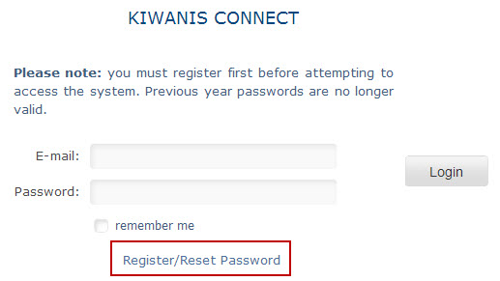
- Key Club: www.keyclub.org/MUC
Step two: Register and get password
Click on “Register/Reset Password.” The next screen will ask you to enter your email address. You will then receive an email from Portalbuzz, with instructions on how to set a password. If you do not see the message within 1 hour, please email memberservices@kiwanis.org. Make sure to check your spam filters for the message.

Step three: Log in and update your roster
Access the system with your email address and password and begin updating your roster. Follow the links on the screen. You can add or delete several members at a time, or one-by-one.

Step four: Send your payment
Finalize your roster by clicking Roster Complete - Print Invoice. You can then either pay online with a credit card, or print an invoice. (Note: If you come back and add more members later, your invoice may still show the members you already added. This is because your check hasn’t been fully processed by Kiwanis International. Simply send in only the amount for the new additions.) Allow 2-4 weeks after your club’s payment for delivery of the new-member pins, cards, and handbooks. Only new members will receive these items.

Step five: Keep using the MUC
As the year goes on, please use the MUC to add members. Important – as soon as you elect new officers to your club, immediately make those changes on the MUC. Doing this will ensure that the new club secretary has access the next fall. If there is a change in advisor, please email member services immediately.

For questions or concerns, please call our Help Line at 1-800-KIWANIS (549-2647), extension 411; or contact us via e-mail at memberservices@kiwanis.org.

